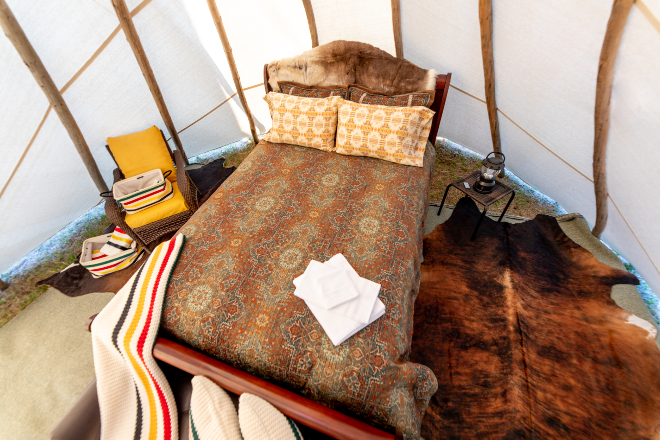



Montana Department of Commerce Tribal Tourism Small Business Grant Program

**Business MT Division Application Guidelines**

**CROW INDIAN RESERVATION**

Table of Contents

I. About the Program 2

II. Program Calendar 2

III. Tribal Tourism Small Business Grant Program 3

A. Summary 3

B. Definitions 3

C. Eligible Applicants 4

D. Ineligible Applicants 4

E. Funding Availability 5

F. Eligible Uses of Program Funds 5

G. Ineligible Uses of Program Funds 6

H. Match Requirement 6

I. How to Apply 6

J. Application Review Process 7

K. Application Review Criteria 7

L. Grant Notification and Contract 9

M. Disbursement of Funds 9

N. Reporting Requirements 10

O. Program Contact 10

# I. About the Program

The Montana Legislature directs the Montana Department of Commerce to encourage economic development and recreational development in Montana’s Indian Country. See [90-1-105](https://leg.mt.gov/bills/mca/title_0900/chapter_0010/part_0010/section_0050/0900-0010-0010-0050.html) and [90-1-104](https://leg.mt.gov/bills/mca/title_0900/chapter_0010/part_0010/section_0040/0900-0010-0010-0040.html), MCA. The Montana Legislature specifically directs Commerce to use a portion of the Montana’s Lodging Facility Use Tax it receives to support tribal tourism in Montana. See also [15-65-121](https://archive.legmt.gov/bills/mca/title_0150/chapter_0650/part_0010/section_0210/0150-0650-0010-0210.html), MCA.

Consistent with that statutory authority, Commerce’s Business MT Division created the Tribal Tourism Small Business Grant Program. These guidelines outline the requirements and policies relating to the application and administration of the TTSB Program.

If you have questions about the Program or these guidelines, contact [doctribal@mt.gov](mailto:doctribal@mt.gov) or go to [commerce.mt.gov/business/indian-country/tribal-tourism](https://commerce.mt.gov/Business/Indian-Country/Tribal-Tourism).

# II. Program Calendar

The following shows the proposed activities and general timelines for TTSB Program process. The timelines may vary a little from year to year. Interested persons are highly encouraged to check the Commerce TTSB website for the annual deadlines: [www.mt.gov/Business/Indian-Country/Tribal-Tourism](http://www.mt.gov/Business/Indian-Country/Tribal-Tourism).

|  |  |
| --- | --- |
| Oct. 1-Nov. 30, 2025 | ServiceNow Grant Application Portal accepting applications: [apply here](https://montana.servicenowservices.com/mtgl?id=sc_cat_item&sys_id=54b13e8e87ac9ad043200f28cebb35c7) |
| Dec. 1, 2025-Jan. 15, 2026 | Rank and review of applications, recommendations to director and the governor |
| Jan. 15-March 15, 2026 | Director and governor finalize award decisions |
| March 15-April 30, 2026 | Award recipients receive award letters and drafting program contracts |
| May 1-31, 2026 | Awards announced in press release; program contracts must be executed by all parties before funds may be distributed |

This schedule is subject to change.

# III. Tribal Tourism Small Business Grant Program

## A. Summary

The purpose of the program is to provide funding to startup or existing Native American businesses that promote or facilitate tribal tourism in Montana. Program funds can be used for a variety of activities as described below. Commerce anticipates awarding up to $240,000 in program funding on an annual basis to eligible applicants. Grantees will receive program funds on a reimbursement basis after incurring eligible costs.

## B. Definitions

These guidelines use the following definitions:

**Tourism:** The act or practice of traveling away from home to a destination for the purpose of a vacation from, or pause in, life’s obligations associated with being at home, such as employment and routine domestic activities. This act or practice typically involves a duration of time that may necessitate overnight accommodations and services, such as the purchase of gas or transportation, food and lodging. Therefore, this act or practice typically contributes to the economy, tourism industry and personal fulfillment, edification or rest. Motivations for engaging in tourism may involve culture, leisure, recreation, natural wonders, events, entertainment, patronizing local businesses and exchanges with the residents who live and work along the route to, from and in the destination.

**Tribal tourism:** The unique experience of traveling away from home for visitation to tribal communities with the motivation to engage with the tribal citizens, support their businesses and local economy and witness their cultural practices, traditions, celebrations, knowledge, history and lands.

## C. Eligible Applicants

Enrolled members of Montana’s federally recognized tribes residing in Montana, aged 18 years or older, may apply for program funds on behalf of their for-profit businesses.

## D. Ineligible Applicants

The following entities are ineligible to apply for program funds:

* Nonprofits
* For-profit businesses that are owned or controlled by individuals who are not enrolled members of Montana’s federally recognized tribes and residing in Montana
* Governmental units
* Any business that is debarred, suspended, proposed for debarment or declared as ineligible to receive State of Montana funds
* Any business that is under a garnishment order from the Montana Department of Revenue for monies owed to the State of Montana
  + Examples of garnishment include taxes owed to the State, child support payments that are past due and funds owed to the university system.
* Any business not registered with the Montana Secretary of State
* Any applicant who submits an incomplete application

## E. Funding Availability

Applications will be accepted from Oct. 1-Nov. 30, 2025. Check the website for more specific deadline details.

Applicants can request up to $10,000 of the $240,000 in total available program funds. The total number of awards per cycle is dependent upon each award amount and the total number of applications submitted. Commerce’s goal is to fund at least 24 awards with an average of three awards per tribal nation.

## F. Eligible Uses of Program Funds

Program funds may be used for one of five eligible tribal tourism business categories listed below:

1. Native American Made in Montana retail sales products
2. Hosted accommodations or experiences, such as vacation rentals or tours
3. Licensed outfitting or guiding in the hunting or fishing industries
4. Licensed food and/or beverage or grocery businesses like food trucks
5. Other operational businesses associated with supplying or serving tribal tourism in Montana

**Business activities may include:**

* Purchase of equipment
* Inventory and supplies
* Building renovations or improvements such as flooring installations, wall repairs, plumbing and electrical systems
* Signage, lighting, security systems, displays and organizational systems
* Business branding, website development, logo design and promotional materials
* Recreational, livestock and storage trailers

## G. Ineligible Uses of Program Funds

Ineligible use of program funds include, but are not limited to, the following purposes:

* Any ongoing or monthly general operating expenses such as wages and taxes
* Any reimbursement for travel expenses
* Costs related to refinancing, servicing or interest on any debt
* Any undertaking not outlined in the contract scope of work or prohibited by the contract signed by the grantee and Commerce, or that is inconsistent with other Commerce directives
* Any costs incurred prior to the date the application is submitted to ServiceNow
* Purchase of real property such as land
* Motorized vehicles not directly related to the tribal tourism business operations
* Livestock
* Any undertaking prohibited by Montana or federal law
* Any undertaking that does not meet all federal, state and local building, food safety and regulatory requirements

## H. Match Requirement

There is no match requirement for this program.

## I. How to Apply

Applications must be completed online through the Montana Grants and Loans Portal located at [montana.servicenowservices.com/mtgl](https://montana.servicenowservices.com/mtgl).

Applicants will be required to create an OKTA profile which requires a valid email account. OKTA is located at [okta.loginmt.com](https://okta.loginmt.com/).

Eligible applicants are encouraged but not required to utilize a Native American Business Advisor to assist them with their application.

The grant cycle and application portal opens Oct. 1, 2025, and closes Nov. 30, 2025.

Applicants must upload all required documentation including a comprehensive business plan, complete all required application fields and follow application instructions for submission to be considered complete. NABAs are available on each reservation and to Little Shell tribal citizens to provide business counseling and assistance with various aspects of the application such as marketing, development of cash flows and financial information, application preparation and training in the ServiceNow online application submission process.

## J. Application Review Process

Once an application is submitted, Commerce reviews it for completeness and clarity. Commerce staff may contact the applicant to request additional information during the review process to aid in the evaluation process.

Commerce evaluates applications utilizing the review criteria established below and makes funding recommendations to the director, who makes the final funding decision. Awards are finalized by the governor, whose office issues award letters.

## K. Application Review Criteria

The following criteria will be used to evaluate the quality of proposals for potential funding:

1. Applicant’s business experience, education and background
2. Overall professionalism, creativity, uniqueness and need for business or services in the community
3. Why locals in the service area, the community and tourists support the business and become customers
4. Business plan, marketing plan, budget for proposed use of program funds and industry research or knowledge
5. Location(s), hours of operation to include days and seasons and total employees
6. Financial projections, operating costs and potential profits
7. Timeline of business activities from preparation to launch
8. List of anticipated purchases with specifics on what, why, how much, where and when
9. Financial need

Additional considerations for eligible projects:

* All applications must include documentation of tribal enrollment in the form of a Certified Indian Blood Form or tribal ID. An application will be considered incomplete without this information.
* All applicants must register their business with the Montana Secretary of State’s Office prior to submission of application and will provide proof of registration as an attachment to the application.
* All applicants must register their business with the Montana Secretary of State’s Office within 60 days of notification of the award and must provide proof of registration before Commerce will execute a contract.
* An application for program funds must demonstrate a reasonable justification for the use of funds. Please round request to the nearest $100 increment.
* With the exception of the Little Shell Tribe of Chippewa Indians enrolled citizens, businesses with a physical address located within a 50-mile radius of the exterior boundaries of an Indian Reservation located within Montana will receive higher consideration over those located outside a 50-mile radius of reservation boundary. All applicants must provide proof of residency.

## L. Grant Notification and Contract

After the successful completion of the review process, Commerce will notify all successful applicants, i.e., grantees of program award, by sending a formal award letter. Once award letters are sent, grantees must sign the contract required by Commerce to receive program funds. Contracts must be executed no later than June 30. Grantees have 24 months from the date the contract is fully executed to completely spend the program funds, which will be issued on a reimbursement or partial advance once the grantee submits sufficient documentation to Commerce. Commerce will consider extensions on a case-by-case basis that must be approved through a contract amendment. For eligible applicants with new businesses, their bank account must be established prior to receiving any program funding.

## M. Disbursement of Funds

Grant funds are paid on a reimbursement basis. No funds are paid directly upfront to grantees. Grant funds are intended to be expended within two years of the contract execution date.

Grant funds are reimbursed to the grantee with the submission of the following complete documentation:

* W-9 (with first request only if not already on file)
* EFT Form with banking information or mailing address (with first request only)
* Completion and submission of required forms and related receipts:
  + Request for Reimbursement Form
  + Project Receipt Worksheet with receipts
  + Project Status Update Report

Forms are available for download at [indiancountry.mt.gov](https://commerce.mt.gov/Business/Indian-Country/).

## N. Reporting Requirements

Project progress reports, status updates, project completion, closeout form and reporting are as follows:

1. **Project progress reports and status updates with receipts worksheets:** During the term of the TTSB contract, the grantee will submit project progress reports and receipts worksheets with required documentation to Commerce in conjunction with each request for reimbursement. These forms will be available for download from Commerce’s website.
2. **Project completion and closeout form and reporting:** Upon completion of the project or within two years from the TTSB contract execution, whichever occurs first, the grantee must submit their Final Project Completion and Closeout Form for Commerce review. Upon approval of the Project Completion and Closeout Report, Commerce will issue the grantee a notice of project closeout.

## O. Program Contact

Rachelle Brown

Tribal Tourism Officer

Office of Indian Country Economic Development

Montana Department of Commerce

P.O. Box 200533

301 S. Park Ave.

Helena, MT 59620-0533

Phone: 406-841-2734

Email: rachelle.brown@mt.gov

Website: [indiancountry.mt.gov](http://www.indiancountry.mt.gov/)