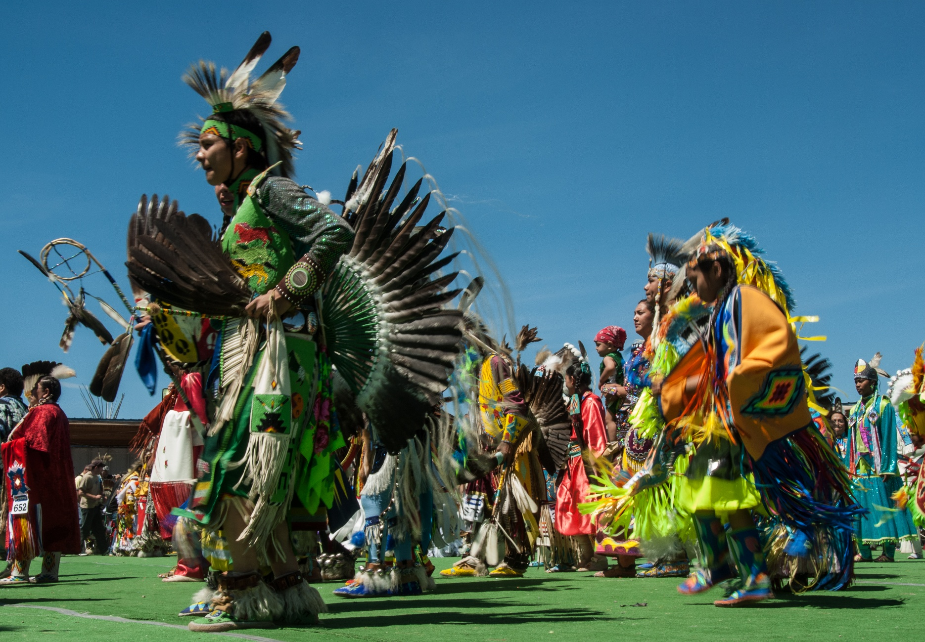




BLACKFEET INDIAN RESERVATION
Montana Department of Commerce
Tribal Tourism Grant Application Guidelines
Table of Contents
I. Overview 3
II. Tribal Tourism Grant 3
A. Summary 3
B. Eligible Applicants 4
C. Ineligible Applicants 4
D. Funding Availability 4
E. Eligible Tribal Tourism Projects 5
F. Ineligible Activities 6
G. Match Requirement 6
H. How to Apply 6
I. Application Review Process 7
J. Application Review Criteria 7
K. Grant Notification and Contract 8
L. Disbursement of Funds 8
M. Reporting Requirements 9
N. TTG Contact 9

I. Overview

The Tribal Tourism Program objectives, goals, strategies and metrics focus on elevating the brand, expanding opportunities and inspiring visitation to the eight tribal nations through the designed seventh tourism region in Montana, the Indian tourism region. The program, under the direction of Commerce’s Business MT Division, ICED, the State-Tribal Economic Development Commission and the Tourism Advisory Council, administers tourism development and promotion activities on behalf of the Indian tourism region.

The Indian tourism region activity functions are administered by Commerce (90-1-104, MCA), to advance tourism development priorities for Montana’s tribes through funding under the Tribal Tourism Grant as authorized by 15-65-121(2)(h), MCA. Activities are funded through a 0.5% allocation of Montana’s Lodging Facility Use Tax collections.

II. Tribal Tourism Grant

A. Summary
The Tribal Tourism Grant is a competitive grant opportunity to connect participating tribes of Montana with the resources necessary to advance one or more self-identified tourism priorities. Approximately $150,000 is available to fund projects defined under Section E, “Eligible Tribal Tourism Projects” on an annual basis.

The deadline for submitting grant applications is Nov. 30, 2026

B. Eligible Applicants
Governing bodies of the federally recognized tribes in Montana are eligible to apply and receive TTG funds unless the applicant received a TTG award the previous cycle. Any applicant in arrears or default with the State of Montana, including State-administered programs, is ineligible. Applicants must establish an OKTA account to access the application portal, by following these instructions: business.mt.gov/_shared/iced/docs/tbdg/oktainstructions.pdf.

C. Ineligible Applicants
Nonprofits are ineligible to apply. The TTG is not intended for tribal member-owned small businesses or for economic development activities not related to tourism. Tourism-related tribal member owned small business projects may be eligible under the Indian Equity Fund and Tribal Tourism Small Business Grant programs administered by Commerce.

D. Funding Availability
Total funding available varies based on the 0.5% of the lodging facility use tax revenue; averaging approximately $150,000 annually. Applicants may request a maximum of $150,000; however, actual grant awards may be less than requested. All grants are dependent upon the availability of funding. For this reason, Commerce encourages applicants to consider contingency funding sources when preparing their project budgets. Actual grants will depend on the number of applications received and the discretion of Commerce.

Please visit the ServiceNow Grant and Loans application platform for more specific deadline details: montana.servicenowservices.com/mtgl.

E. Eligible Tribal Tourism Projects
The applicant’s project must be either (1) destination development and infrastructure updates or (2) product development and technology systems. Eligible project activities must be shovel-ready and long-lasting. Examples of eligible project activities include, but are not limited to:

- Destination development and infrastructure upgrades
- Establishing new or improving existing campgrounds, expanding rental features like tipi rentals, small cabins and/or RV parks with upgraded amenities like electrical hookups, potable water, grey water disposal, restroom facilities, showers, picnic pavilions, fire rings, tent pads, camp host residence, facilities maintenance equipment and/or vehicles, gift shop or visitors center with point-of-sale system for purchases.
- Historical markers with areas for travelers to stop and rest with shade and/or use the restroom at a vault toilet or access potable water.
- Interpretive trails with informational kiosks on flora, fauna or historical significance.
- Agritourism offerings such as certified guided fishing, hiking, hunting, horseback riding, bison range tours, stargazing, bird watching, bicycle tours and boat tours.
- Improved ADA accessibility at existing locations.
- Product development and technology systems
- Certified guide curriculum and course certification program offered at a tribally owned college or within the tribe’s historic preservation department.
- Tribal tourism website where visitors can explore offerings, view a frequently asked questions section, see a map of locations and promoted events like pow wows and Indian relay races, check posted travel alerts, use a booking system for tours or campground reservations and make electronic payments.

F. Ineligible Activities
Examples of ineligible activities that will not be funded include but are not limited to the following:
- Activities completed prior to date of application submission.
- Activities not related to the TTG contract scope of work.
- Activities that do not deliver on the objectives of the grant or are not related to the submitted application.
- Duplicative reimbursement for activities receiving funding for the same services, equipment or improvements through any other local, state or federal grant or funding program, except as necessary to fully fund the project.
- Wages, meals, transportation, lodging and mileage reimbursements.
- Land and livestock purchases.

G. Match Requirement
No match is required for awards of $25,000 or less. For awards greater than $25,000, the match requirement is a minimum of 10% of the award total, $1 applicant match to $10 of the award. Reasonable in-kind services, in-kind labor and/or volunteer hours, land, equipment and cash are eligible for the match requirement.

H. How to Apply
Applications must be completed online through the Montana Grants and Loans Portal located at montana.servicenowservices.com/mtgl.

Applicants will be required to create an OKTA profile which requires a valid email account. OKTA is located at okta.loginmt.com.

Applications considered incomplete or ineligible can be reopened for editing and returned to the applicant through ServiceNow prior to the application submittal deadline. Applicants are encouraged to apply early so that they can make any necessary adjustments or changes before the deadline to make their application competitive. Receipt of an application does not imply a commitment of funding. Commerce will review applications for eligibility and compliance with state and grant requirements.

I. Application Review Process
- Receipt of Application: Upon submission, Commerce assesses each application for completeness and clarity. Commerce may contact the applicant to request additional information during the review process to aid in the evaluation process.
- Review: Commerce makes funding recommendations to the director, who makes the award decision. Awards are finalized by the governor, whose office issues award letters.

J. Application Review Criteria
Because this is a competitive grant opportunity, each application is evaluated for its strengths and weaknesses compared to other applications. Review criteria include:
- How well does the applicant define the scope, budget and objectives of the project?
- What challenges must be mitigated to ensure the project’s success?
- How will the project positively impact tourism for the tribal community?
- How well does the project align with and support the tribe’s greater economic development plans?
- How will the success of the project be measured?
- Has the applicant successfully completed prior TTG projects and contract requirements?

K. Grant Notification and Contract
Applications are reviewed during the month of December, with recommendations for awards beginning January. The review and award process takes approximately 30-90 days. Commerce aims to notify applicants of award decisions by the end of March. The contracting process is expected to be completed no later than May 15. The projects must be completed within 24 months from the date the contract is fully executed. Commerce will consider extensions on a case-by-case basis that must be approved through a contract amendment.

L. Disbursement of Funds
Grant funds are paid on a reimbursement basis. No funds are advanced directly, upfront to grantees. Grant funds should be expended within two years of the contract’s start date.

Grant funds are reimbursed to the grantee with the submission of the following complete documentation:
- W-9 (with first request only if not already on file).
- EFT form with banking information or mailing address (with first request only).
- Completion and submission of required forms and related receipts:
  - Request for Reimbursement Form
  - Project Receipt Worksheet with receipts and invoices
  - Project Status Update Report
Forms are available for download at indiancountry.mt.gov.

M. Reporting Requirements
Required reporting is as follows:

- Project progress reports and status updates: During the term of the TTG contract, the grantee will submit project progress reports to Commerce in conjunction with each request for reimbursement. These forms will be available for download from Commerce’s website.
- Project completion, final project status report, and closeout: Upon completion of the project or within two years from the TTG contract execution, whichever occurs first, the grantee must submit their last request for reimbursement and final Project Status Report Form for Commerce review. Upon approval Commerce will issue any payment due to the grantee and a notice of project closeout for grantee’s signature.

N. TTG Contact
Rachelle Brown
Tribal Tourism Officer
Indian Country Economic Development
Montana Department of Commerce
P.O. Box 200533
301 S. Park Ave.
Helena, MT 59620-0533
Phone: 406-841-2734
Email: rachelle.brown@mt.gov
Website: indiancountry.mt.gov

