EXHIBIT 2-X

ACKNOWLEDGMENT OF RECEIPT

I have received a copy of the pamphlet, ‘Protect Your Family From Lead In Your Home’, informing me of the potential risk of lead hazard exposure from renovation activity to be performed in my dwelling unit. I received this pamphlet before the work began.

Printed Name:

Signature:

Date:

Unit Address:

Certification of Attempted Delivery
(For use when an occupant is unavailable for signature or refuses to sign the acknowledgment of receipt)

Date:

Unit Address:

Method of Delivery of Pamphlet:
Name(s) of the person(s) delivering the Pamphlet:

Reason for lack of acknowledgment: (e.g. occupant refuses to sign, no adult occupant available)

Signature of Renovator:

Date of Signature:

Refusal to Sign Certification

I certify that I have made a good faith effort to deliver the pamphlet, ‘Protect Your Family From Lead In Your Home’, to the unit listed below at the dates and times indicated, and that the occupant refused to sign the acknowledgment. I further certify that I have left a copy of the pamphlet at the unit with the occupant.

Printed Name:

Signature:

Date:

Unit Address:

Attempted Delivery Dates and Times:

Unavailable For Signature Certification
I certify that I have made a good faith effort to deliver the pamphlet, ‘Protect Your Family From Lead In Your Home’, and that the occupant was unavailable to sign the acknowledgment. I further certify that I have left a copy of the pamphlet at the unit by sliding it under the door.

Printed Name:

Signature:

Date:

Unit Address:

Attempted Delivery Dates and Times:

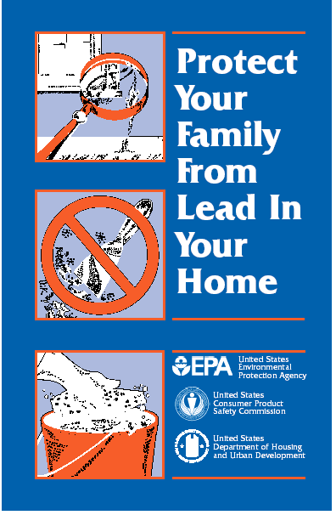
Available on-line at: http://www.epa.gov/lead/pubs/leadprot.htm
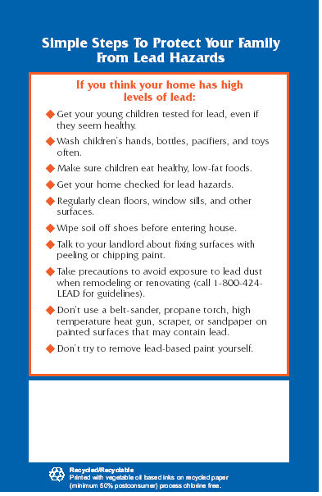
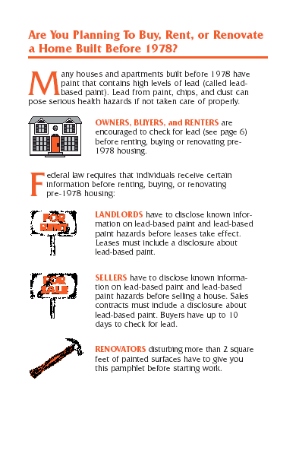
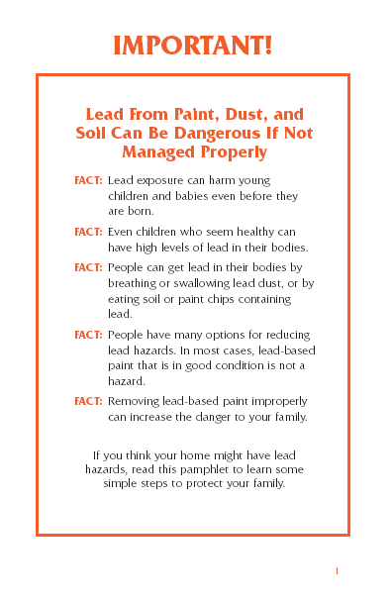
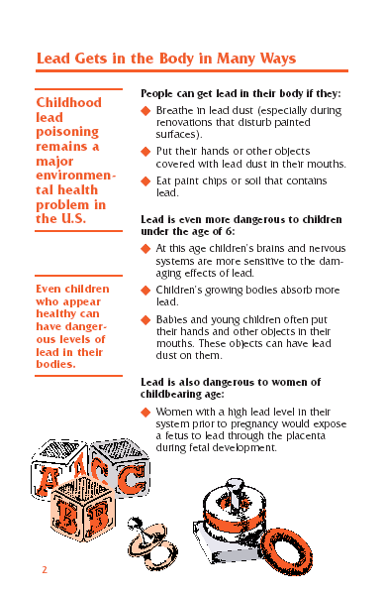
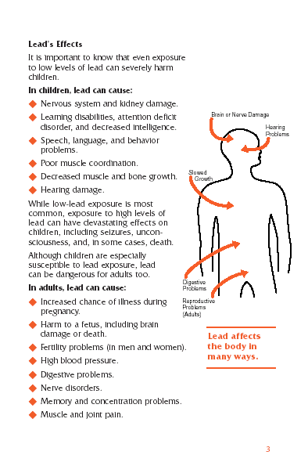
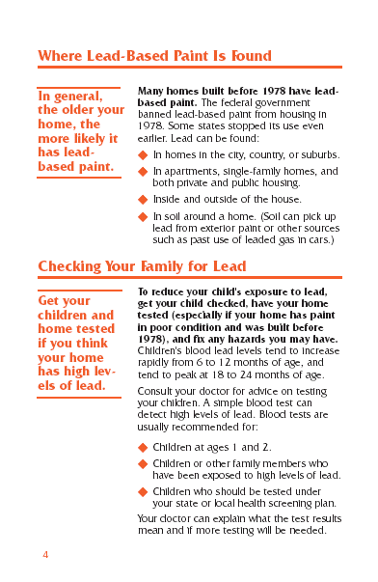
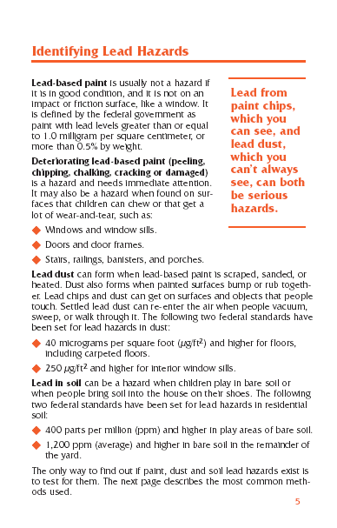
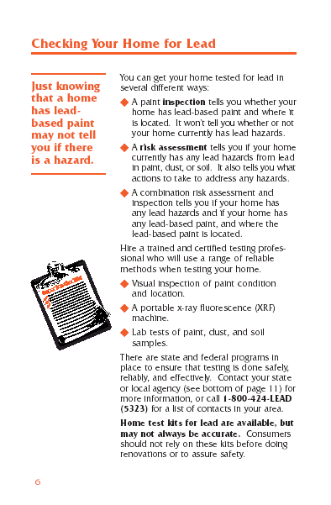
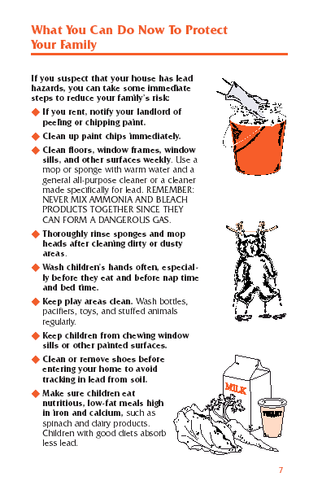
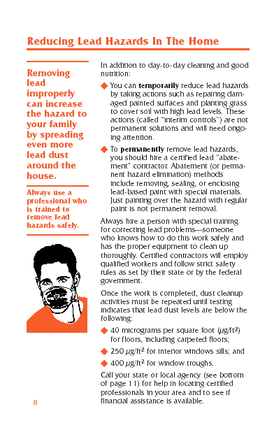
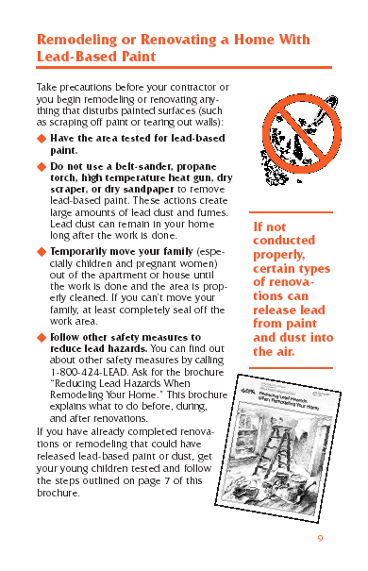
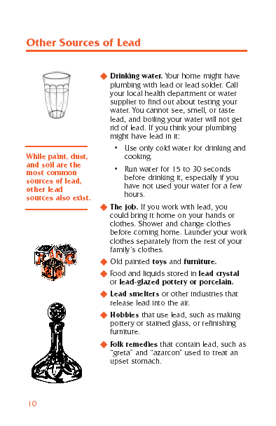
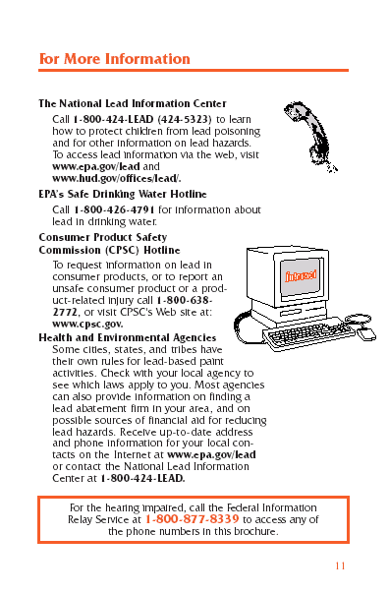
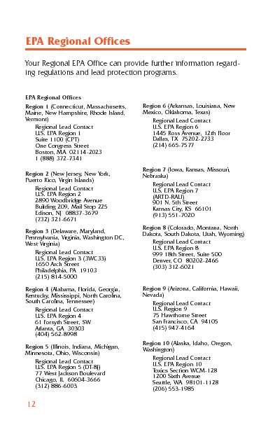
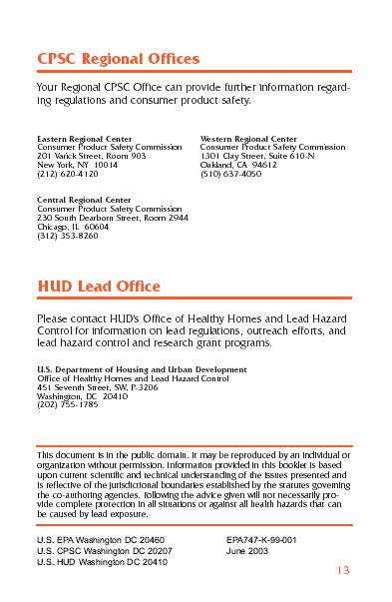
http://www.epa.gov/lead/pubs/leadprot.htm

