**A Meeting of the Montana Heritage Commission**

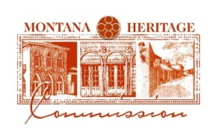

**AGENDA**

Thursday, November 14, 2024

12:00 PM - 1:00 PM

VIA [ZOOM](https://mt-gov.zoom.us/j/82862976076?pwd=Lposytlvu1EXvxtLtSB3unQFu1v2Ik.1)

12:00 Call to Order/Roll Call

Notice of Meeting

12:05 Discussion on Board Leadership

12:10 Discussion on Stonewall Hall Advisory Committee

12:30 Public Comment

12:40 Vote on Stonewall Hall Approval

12:50 Public Comment

12:55 Next Meeting

1:00 Adjourn