MONTANA FACILITY FINANCE AUTHORITY
Board Meeting

ZooMontana
2100 Shiloh Rd. Billings, MT 59106

October 22, 2026

“Enhance Montana healthcare and community capabilities through access to cost-effective capital financing and development services.”



MEMORANDUM

To: MFFA Board Members
From: Adam Gill, Seth Lutter, Monica Birlut, and Carolyn Jones
Date: October 14, 2026
Subject: MFFA Board Meeting Thursday, October 22, 2026 at 9:00 AM at Zoo Montana

Enclosed, please find board meeting materials for our upcoming MFFA Board Meeting:

We get to be out in the field for this meeting! We will have a tour of the current construction of St. Vincent’s Hospital on Wednesday afternoon. And we will hold our Board Meeting on Thursday at ZooMontana which will also provide us with a behind the scenes tour of their facilities after the meeting.

We have a stand-alone bond issuance to consider alongside our regular reports. Zoo Montana in Billings is seeking approximately $4 million in Stand Alone Program bonds to construct a new veterinary care building. We also have inducement resolutions for Minot Cement Company and Tripp Lumber and we will review our normal updates and reports.

Wednesday:
4:00 PM - Tour St. Vincent’s Hospital Construction – meeting location TBD
6:30 PM – Dinner (location TBD)

Thursday:
9:00 AM – Board Meeting at ZooMontana followed by a tour of the zoo.

As always, please call or write if you have any questions.
MICROSOFT TEAMS INSTRUCTIONS
Conference Link: https://teams.microsoft.com/meet/296615539200937?p=0lwdJ9qvAVFQDBLfqv

Meeting ID: 296 615 539 200 937; Passcode: HW2QK37r
OR
Dial by Telephone: +1 406-318-5487,,671423525#

MONTANA FACILITY FINANCE AUTHORITY
Board Meeting
October 22, 2026

Zoo Montana
2100 Shiloh Rd.
Billings

MEETING AGENDA

9:00 I. CALL TO ORDER
- Roll Call
- Approval of Meeting Minutes (8/11)
- Disclosure and Conflict of Interest

II. PUBLIC COMMENT on Board Related Items

III. FINANCINGS
- SRAI Bozeman, LLC on behalf of the National Finance Authority
  - Resolution No. 26-08
Joining Virtually:
Margaret Darby, Bond Counsel – Thompson Burton PLLC
- Zoo Montana
  - Loan Summary
  - Resolution No. 26-09
Joining:
Jessica Hart, Executive Director – Zoo Montana
Pete Bolenbough, Development Director – Zoo Montana
Tom Potter, Vice-President – Bravera Bank
Nathan Bilyeu, Bond Counsel – Jackson, Murdo & Grant
B. Minot Cement
- Resolution No. 26-10
Joining:
Nathan Bilyeu, Bond Counsel – Jackson, Murdo & Grant
C. Tripp Lumber
- Resolution No. 26-11
Joining:
Nathan Bilyeu, Bond Counsel – Jackson, Murdo & Grant
MICROSOFT TEAMS INSTRUCTIONS
Conference Link: https://teams.microsoft.com/meet/296615539200937?p=0lwdJ9qvAVFQDBLfqv

Meeting ID: 296 615 539 200 937; Passcode: HW2QK37r
OR
Dial by Telephone: +1 406-318-5487,,671423525#

IV. GENERAL ADMINISTRATIVE
A. Financials
- Budget -v- Actual
- Revenue Graph
- Reserve Balances
- Staff Approved Loans & Grants

B. Miscellaneous
  - Outreach & Marketing Report
  - Anticipated Financings

10:30 DISMISS & Zoo Montana Tour

MONTANA FACILITY FINANCE AUTHORITY

Board Meeting

August 11, 2026

9:00 A.M.

MINUTES

BOARD MEMBERS
PRESENT: John Iverson
Vu Pham (online)
William Northey (online)
Eric Hanson (online)
JoAn Cuffe
Craig Anderson (online)
Mel Reinhardt (online)

BOARD MEMBERS
ABSENT:

STAFF PRESENT: Adam Gill, Executive Director
Seth Lutter, Associate Director
Monica Birlut, Accountant
Carolyn Jones, C-PACE Program Manager

GUESTS: Nathan Bilyeu, Authority Counsel – Jackson, Murdo & Grant
Grace Berner, Authority Counsel – Jackson, Murdo & Grant
Nathan Coburn, CFO – St. Peter’s Health
John Henningsgard, Managing Director – Piper Sandler (online)
Sarah Bartow, Agency Performance Advisor – MT Dept of Admin
Therese Simpson, Business Analyst – MT Dept of Admin
Adam Carpenter, Chief Data Officer – MT Dept of Admin
Ed Buttrey, CEO – Montana Hospital Association

BOARD MEETING

CALL TO ORDER

Board Chair Pham called the August 11, 2026, board meeting of the Montana Facility Finance Authority (the “Authority”) to order at 9:00 A.M. The meeting convened with all the Board Members present.

Minutes

Board Member Northey moved for approval of the June 16, 2026, board meeting minutes. Board Member Reinhardt seconded the motion which passed unanimously.
CONFLICT OF INTEREST

Call was made for announcement of any conflict of interest and recusals. Board Member Northey noted a potential conflict. Nathan Bilyeu, Authority Counsel provided guidance that the indirect conflict would not be material enough to require recusal. Board Member Anderson noted a potential conflict and recused himself. Chair Pham noted a potential conflict, but Mr. Bilyeu provided guidance that the indirect conflict would not be material enough to require recusal

PUBLIC COMMENT

The meeting was opened for public comment. No comments were received.

FINANCINGS

St. Peter’s Health

Mr. Gill introduced Nathan Coburn, CFO – St. Peter’s Health and John Henningsgard, Managing Director – Piper Sandler (online) and asked Mr. Coburn to provide a description of the project and structure of the financing. The project is to finance a reimbursement of past expenditures related to office space and for a future emergency room expansion and remodel.

Board Chair Pham requested a motion for approval of Resolution 26-07. Board Member Iverson motioned for approval of the financing Resolution 26-07. Board Member Cuffe seconded the motion. Mr. Bilyeu described Resolution 26-07 which passed with Board Member Anderson abstaining from voting.

GENERAL ADMINISTRATIVE

Educational

Ed Buttrey, CEO – Montana Hospital Association presented on the Rural Health Transformation Program, the five pillars of funding, the anticipated outcomes, and the expectation of changes of healthcare in Montana.

Financials

Mr. Gill presented the Budget-v-Actual results, the Reserve Balances, and the Revenue Graph.

Strategic Planning

Mr. Gill introduced Sarah Bartow, Agency Performance Advisor – MT Dept of Admin, Therese Simpson, Business Analyst – MT Dept of Admin, and Adam Carpenter, Chief Data Officer – MT Dept of Admin. Ms. Bartow discussed the process for MFFA’s strategic planning development. The board and staff then discussed and added to MFFA specific goals and objectives for calendar year 2027 and finalized the strategic plan for distribution.

ADJOURN

The meeting adjourned at 11:20 A.M.

APPROVE: _______________________ ATTEST: ________________________
Vu Pham, Board Chair Adam Gill, Executive Director

APPROVAL DATE: ________________

RESOLUTION NO. 26-08
A RESOLUTION AUTHORIZING A PUBLIC HEARING UNDER SECTION 147(f) OF THE INTERNAL REVENUE CODE OF 1986, AS AMENDED, ON BEHALF OF SRAI BOZEMAN, LLC
WHEREAS, the Montana Facility Finance Authority (the “Authority”) is authorized by § 90-7-202(21), Montana Code Annotated, to perform “acts necessary and convenient to carry out the purpose of this chapter,” with such purposes including facilitating access to affordable financing for economic development projects located in Montana, including airport and aviation facilities;
WHEREAS, SRAI Bozeman, LLC, a Delaware limited liability company, an affiliate of SRAI OG, LLC, a Delaware limited liability company, or one or more subsidiaries or other affiliates thereof, an aircraft hangar developer throughout the United States (the “Borrower”), has proposed that the Authority hold a public hearing in accordance with Section 147(f) of the Internal Revenue Code of 1986, as amended, and regulations applicable thereto (a “TEFRA Hearing”) in regards to tax-exempt bond issuances for the purpose of funding, in part, the following project:
Development of an airport facility consisting of a new approximately 40,000-square-foot single-story pre-engineered clear-span metal building hangar on approximately 2.7 acres, with related ancillary office space and associated asphalt ramp and parking areas at Bozeman Yellowstone International Airport, all located on land leased from the Gallatin Airport Authority at 205 Airport Road, Belgrade, Gallatin County, Montana 59714– $25,000,000.
NOW, THEREFORE, BE IT RESOLVED BY THE MONTANA FACILITY FINANCE AUTHORITY, AS FOLLOWS:
1. The Authority determines that holding a TEFRA Hearing regarding the above-described airport facility project would further the purpose of facilitating access to affordable financing for airport and aviation facilities in Montana.
2. Executive Director Adam Gill, or his successor or other appointed employee of the Authority as he shall designate, is hereby authorized to hold a TEFRA Hearing and do all things reasonably necessary, in consultation with counsel to the Authority and counsel to the Borrower, to ensure that the TEFRA Hearing is properly noticed and administered and that the subsequent TEFRA approval by the Governor’s office, if any, is properly and duly documented and attested.

Passed and approved by the Authority this 22nd day of October, 2026.
MONTANA FACILITY FINANCE AUTHORITY

By: _______________________________
Vu Pham
Its: Chairman
ATTEST:

_______________________________
Adam Gill
Its: Executive Director

ZooMontana, Inc.

Billings, Montana

Economic Development Bond

Loan Summary

Eligible Facility

Located in Billings, Montana, ZooMontana, Inc. (the “Zoo”) operates the only zoological and botanical park within a 500-mile radius of Billings, MT. Incorporated in 1984, ZooMontana is a nonprofit 501c (3) organization.

The Zoo is amongst the few municipal zoos that do not receive funding through taxes or levies, relying instead on contributions and grants, admissions, events, and gift shop sales for revenue generation. In September 2019, ZooMontana achieved accreditation from the Association of Zoos & Aquariums (“AZA”), reflecting adherence to the highest standards of animal welfare, conservation, education, and operational excellence. The Zoo is home to over one hundred animals representing fifty-six distinct species, including tigers, bears, wolves, sloths, and others. The majority of the Zoo’s animals are rescues. Annually, the Zoo serves over 150,000 visitors and provides community and educational programming to more than 18,000 students.

Project and Cost

The MFFA received a bond application on 9/15/2026 requesting $4 million to finance the construction of a new 3,600 sqft veterinarian clinic. The new facility will allow the Zoo to service its own animals efficiently and safely. It will ultimately result in cost savings since the Zoo will not have to transport its animals or pay outside veterinarians for services. The bond will be a private placement with Bravera Bank which has already approved the financing internally.

ZooMontana currently outsources its veterinary care to a local practice, which is common for a zoo its size. However, as the Zoo continues to grow, it sees the need for a veterinarian to be an on-staff position. This will allow ZooMontana to provide more consistent care for its animals as well as building a stronger relationship between a veterinarian, the staff, and the animals.

The Zoo currently has no dedicated medical spaces on campus. The clinic will be the primary space where medical procedures occur, as well as be home to the veterinary care team. In addition to the care space, the building will house much needed quarantine space for new animals and sick animals that are medically required to segregate from the rest of the population as well as classroom space with a viewing window to further the partnership with the Rocky Vista University Veterinary School. Classroom space will also open the door for other organizations to use the facility for educational programs.

Sources/Uses

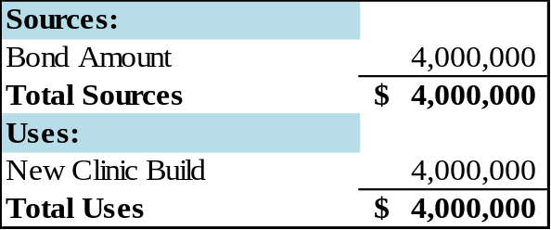

Program Private Placement Economic Development Bond

Loan Term 25-year maturity with 10-year amortization

Interest Rate 5% with potential 5-year rate adjustments

Closing date Est. Spring 2027

Maturity Date Est. 2052

Security

The loan will be an economic development bond privately placed with Bravera Bank and will be secured by Zoo property consisting of 56 acres with improvements. The tax assessed value is $17 million prior to the proposed new building.

Financials

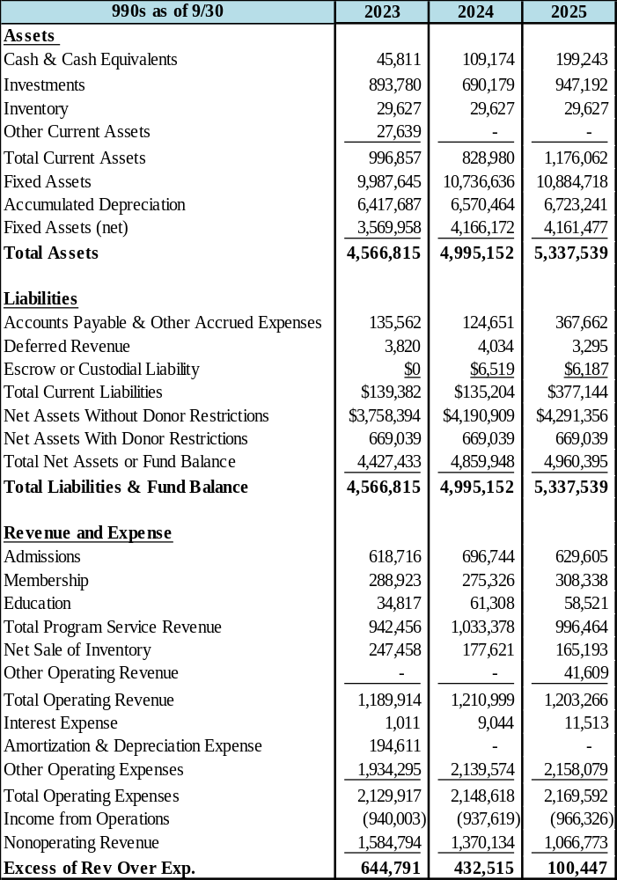

Interim Financials

Interim financials through 04/30/2026 reflect six months of the borrower’s operating performance. Year-to-date revenues total $1.80 million and are on pace to exceed prior fiscal year results. Revenue continues to be primarily driven by contributions and grants of $1.20 million, supplemented by program service revenues of $395,000. Expenses remain steady and are largely comprised of wages. The Zoo is currently reporting a net profit of $280,000 Year-to-date liquidity remains strong, with the current ratio improving to 5.54, primarily due to increased cash balances of $1.50 million. The borrower’s only outstanding debt continues to be the donor loan, and leverage remains minimal, as reflected by a debt-to-equity ratio of 0.07. Equity remains robust at $5.60 million, consisting of $4.90 million in unrestricted net assets and $669,000 in restricted net assets. Bravera Bank believes repayment capacity has strengthened significantly and the Zoo has the ability to pay.

Financial Observations

- Lower non-operating revenues year-over-year is primarily driven by decreased donor contributions and grants which totaled $1 million in FY 2025, representing a decrease of $111,000 from the previous fiscal year.
- Program service revenues, consisting of admissions, memberships, and education offerings, have stayed relatively stable.
- Sales of inventory have decreased over the same period, reflecting reduced inventory sales, with sales declining from $247,458 in FY 2023 to $177,621 in FY 2024 and staying stable at that point.
- Operating expenses (excluding depreciation) remain well managed and are primarily concentrated in wages, which totaled $801,000 and represented approximately 37% of total expenses. Despite the modest decline in revenues, the Zoo is seeing revenues over expenses.

Operating Revenue Mix

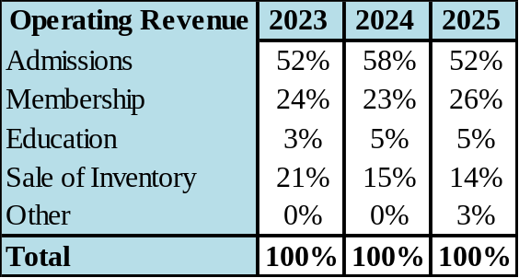

Ratios

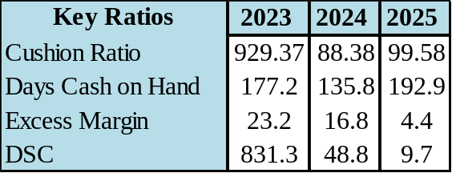

Pro Forma

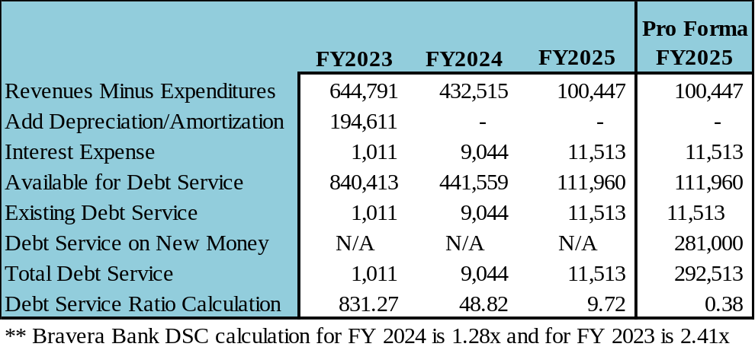

Projections

ZooMontana estimates a $60,000 net positive effect on cash flow due to the vet clinic. The Zoo spends $125,000 annually on outside vet services. By hiring an on-staff vet for $115,000, the Zoo will see a $10,000 savings. There is an estimated $10,000 savings on vet supplies as well as an estimated $40,000 revenue increase in vet-related education and event income. The pro forma isn’t showing the increased projected revenue.

Governance / Management

The ZooMontana Board consists of no less than five and no more than twelve voting members. Board members are elected to a term of three years and are eligible to serve two consecutive terms. Once a board member has been on the board for one full year, they are eligible for board service again with the same applicable term limits. While no formal matrix or selection criteria are used, the ZooMontana board is comprised of professionals from a variety of industries such as tourism/hospitality, banking/finance, legal, insurance, etc. This allows for a wide range of perspectives and voices at the table when discussing the best strategic priorities for ZooMontana.

Jessica Hart, President & CEO – Ms. Hart serves as President and CEO of ZooMontana. She joined the Zoo in 2020 and has held progressively responsible leadership positions within the organization, including oversight of operations, before assuming the role of President and CEO in 2025. Hart provided leadership through ZooMontana’s most recent AZA reaccreditation process and continues to guide the organization’s operational growth and long-term development. She holds a Bachelor of Science in Community Health from Montana State University and previously worked with several nonprofit organizations in the Billings community.

Travis Goebel, Curator – Mr. Goebel serves as Animal Curator at ZooMontana, where he provides leadership for animal care and management of the Zoo’s living collection. After graduating from Northland College in 2001 as a double major in Psychology and Biology, he moved to Montana to begin an internship with ZooMontana. He has spent 25 years with the organization, gaining extensive experience in zoological animal care and management. During his tenure, he has helped lead ZooMontana through significant organizational challenges, including the achievement and continued maintenance of AZA accreditation and the development of evolving animal-care practices.

Pete Bolenbaugh, Chief Growth and Development Officer – Mr. Bolenbaugh serves as Chief Growth and Development Officer for ZooMontana, where he oversees development, sponsorships, planned giving, and other initiatives supporting the organization’s long-term growth and financial sustainability. He brings professional experience in nonprofit leadership, major-gift fundraising, and organizational development, including serving as Director of Major Gifts at Rocky Mountain College and Executive Director of Wise Wonders in Billings. He received a Physics degree from the University of Montana.

Finance Team Members

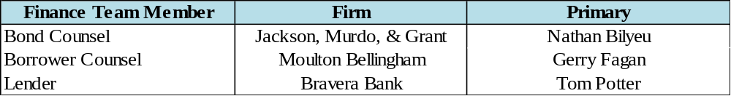

Strengths

- Reputable business with years of experience
- Great relationship with the lender who also donates to the Zoo
- Growth and self-sustaining potential due to project

Weaknesses

- Does not have a strong cash position
- Large investment for an organization this size

Recommendation

- Approval of the financing is recommended based upon the Borrower’s plans to retain costs in an industry it already thrives in, the strength of its leadership team and the potential savings and revenue from its project.

RESOLUTION NO. 26-09

RESOLUTION RELATING TO A VETERINARY FACILITIES REVENUE BOND (ZOOMONTANA VETERINARY CLINIC PROJECT) SERIES 2026; MAKING FINDINGS WITH RESPECT TO the PROJECT AND the BOND; AUTHORIZING AND APPROVING THE SALE AND ISSUANCE OF THE BOND SECURED BY a mortgage and by PAYMENTS TO BE RECEIVED PURSUANT TO A LOAN AGREEMENT; AND AUTHORIZING THE EXECUTION OF DOCUMENTS.

BE IT RESOLVED by the Montana Facility Finance Authority (the “Authority”), as follows:

ARTICLE I

RECITALS

Section 1.01. The Authority is authorized by Montana Code Annotated, Title 90, Chapter 7, Parts 1, 2 and 3, as amended (the “Act”), to issue and sell its revenue bonds and loan the proceeds thereof to one or more institutions (as defined in the Act) to finance, refinance or provide reimbursement for certain allowable costs of acquiring, constructing and equipping eligible facilities (as defined in the Act). Bonds so issued are payable solely from the revenues and assets derived from the participating institutions (as defined in the Act) and do not constitute a debt, liability or obligation of the State of Montana (the “State”) or a pledge of the faith and credit thereof. The Authority is required to secure the bonds by pledging the revenues received from the participating institutions. The Authority may also secure the bonds by mortgages, assignments and other security devices deemed advantageous by the Authority pursuant to a trust agreement between the Authority and a corporate trustee.

Section 1.02. ZooMontana, Inc. (the “Corporation”) is a Montana nonprofit corporation authorized to do business in the State.

Section 1.03. The Corporation desires to construct and equip a new veterinary clinic located at 2100 S. Shiloh Rd, Billings, MT 59106 (the “Project”). Consequently, the Corporation has requested that the Authority, acting pursuant to and in accordance with the Act, authorize the issuance of its Montana Facility Finance Authority Veterinary Facilities Revenue Bonds (ZooMontana Veterinary Clinic Project) Series 2026 (the “Series 2026 Bond”), in a principal amount not to exceed $4,000,000, the proceeds of which will be loaned by the Authority to the Corporation to fund a portion of the costs of the Project (the “Loan”). Under the provisions of the Act, the Series 2026 Bond shall be a special, limited obligation of the Authority payable solely from revenues, including loan repayments from the Corporation, and shall not constitute a debt, liability, obligation or pledge of the faith, credit or taxing powers of the State. The Corporation also anticipates contributing available cash to fund the costs of issuance and any other costs of the Project not covered by the Loan.

Section 1.04. The Authority has heretofore called and noticed, and intends to conduct, a public hearing as required by Section 147(f) of the Internal Revenue Code of 1986, as amended (the “Code”), with respect to the financing of the Project and the issuance and sale of the Series 2026 Bond. At the public hearing, all persons who appear will be afforded an opportunity to express their views with respect to the proposal to issue the Series 2026 Bond to finance the Project. Following the public hearing but prior to the issuance of the Series 2026 Bond, the Governor of the State is expected to approve the issuance of the Series 2026 Bond.

Section 1.05. The following documents relating to the Series 2026 Bond have been prepared, which documents in proposed form have been made available to the Authority and shall be placed on file in the office of the Authority:

(a) The Financing Agreement (the “Financing Agreement”) to be entered into by and between the Authority and the Corporation;

(b) The Loan Agreement (the “Loan Agreement”) to be entered into by and between the Authority and the Corporation;

(c) The Combination Mortgage, Security Agreement, and Fixture Filing Statement (the “Mortgage”), dated as of the date of issuance of the Series 2026 Bond, by and between the Corporation and Bravera Bank (the “Bank”);

(d) The form of the Series 2026 Bond (the “Series 2026 Bond Form”); and

(e) The Tax Compliance Agreement, to be entered into by and between the Corporation and the Authority.

Section 1.06. Unless the context requires otherwise, the terms defined in this Resolution (including the recitals and exhibits hereto) shall have the meanings assigned to them in the Financing Agreement or Loan Agreement, which definitions are incorporated herein by this reference, such definitions to be equally applicable to both the singular and plural forms of any of the defined terms.

ARTICLE II

FINDINGS

Based on information provided by the Corporation and such other facts and circumstances as the Authority deems relevant, the Authority hereby finds, determines and declares as follows:

(a) The facilities being financed by the Project (the “Project Facilities”) are an “eligible facility” within the meaning of the Act, and will be owned and/or operated by the Corporation, which is an “institution” within the meaning of the Act;

(b) The Loan payments to be made by the Corporation pursuant to the Loan Agreement are scheduled to be sufficient to pay the principal of, and interest on the Series 2026 Bond, when due, to maintain sufficient reserves therefor, to meet all other obligations in connection with the Loan Agreement and to provide for costs of servicing and securing the Series 2026 Bond and the Loan;

(c) The loan of the proceeds of the Series 2026 Bond to the Corporation pursuant to the Loan Agreement will not exceed the total eligible costs of the Project as determined by the Corporation;

(d) Based solely upon information provided and representations made by the Corporation, the Revenues are expected to be sufficient to provide for the payment of the principal and interest on the Loan as due;

(e) Pursuant to the Indenture, the Loan payments and amounts payable under the Loan Agreement are pledged to the payment of the principal of, premium, if any, and interest on the Series 2026 Bond;

(f) Based solely on information provided and representations made by the Corporation, the facilities to be financed by the Project are in compliance with applicable Montana law and regulation and/or Federal law and regulation, and have obtained all required permits or licenses to the extent required by Montana law and regulation and/or Federal law and regulation;

(f) Based solely on information provided and representations made by the Corporation, the facilities being refinanced through the Project did not and do not significantly affect the quality of the human environment, within the meaning of Montana Code Annotated, Section 75-1-201(1)(b)(iii);

(g) The Project Facilities are or will be owned and/or operated by the Corporation for the purpose of fulfilling its obligations to provide veterinary care facilities;

(h) Based solely upon information provided and representations made by the Corporation, the Corporation has sufficient experience and expertise to operate the facilities being refinanced; and

(i) Based solely upon information provided and representations made by the Corporation, the Project is financially feasible, and the Corporation will have sufficient revenues to provide for the payment of the principal of and interest on the Loan, as due.

The foregoing findings and determinations are made pursuant to the Act and are not made for the benefit of, and may not be relied upon by, any owner of the Series 2026 Bond (an “Owner”).

ARTICLE III

APPROVAL AND AUTHORIZATIONS

Section 3.01. Subject to compliance with the terms of the Act and this Resolution, the Project is hereby approved, and the Authority shall make the Loan to the Corporation for the purpose of providing the financial assistance requested by the Corporation therefor. To fund the Loan, the Authority hereby authorizes the issuance of the Series 2026 Bond and the sale of the Series 2026 Bond to the Bank, at par, subject to the following, which the Executive Director is hereby authorized to approve:

(a) the principal amount of the Series 2026 Bond; provided that such principal amount shall not exceed $4,000,000;

(b) the tax-exempt interest rate shall be 5.00% with five (5) year rate adjustments;

(c) the final maturity of the Series 2026 Bond is twenty-five (25) years from the date of issuance of the Series 2026 Bond and shall be based on a twenty-five (25) amortization schedule; and

(d) the provisions for prepayment, purchase, and redemption of the Series 2026 Bond prior to its stated maturity.

Such approval by the Executive Director shall be conclusively evidenced by the Executive Director’s execution of the documents approved herein.

The Series 2026 Bond shall be dated its date of issuance and shall be issued as a single fully registered bond, without number, in substantially the same form as Exhibit B to the Indenture, which is incorporated herein by this reference.

The Series 2026 Bond shall be a special limited obligation of the Authority, payable solely from the money and investments in the Bond Fund.

The State is not liable on the Series 2026 Bond. The Series 2026 Bond is not a debt of the State, and neither the faith and credit nor the taxing power of the State is pledged to the payment of the principal of or the interest on the Series 2026 Bond. The Owner of the Series 2026 Bond shall have no right to compel the exercise of the taxing power, if any, of the State or any political subdivision thereof to pay any principal of or interest on the Series 2026 Bond.

The Series 2026 Bond shall be secured by the Mortgage and by a pledge of the money and investments in the Bond Fund. As additional security for the Series 2026 Bond, the Authority shall assign its rights, title, and interests in the Loan Agreement and all other loan documents to the Owner of the Series 2026 Bond, without recourse, pursuant to the Assignment.

The Series 2026 Bond shall be executed on behalf of the Authority with the facsimile or manual signatures of the Chair and the Executive Director of the Authority and shall be authenticated by an authorized representative of the Registrar.

Section 3.02. The Authority hereby authorizes, accepts, approves and agrees to all the terms and conditions of the following documents, in substantially the forms available to the Authority on this date, with such additions, deletions and modifications as are hereafter deemed by the Chair, the Executive Director and the Associate Director of the Authority, or any one or more of them acting alone or in combination, to be in the best interest of the Authority, which documents authorize, inter alia, the delivery of the Series 2026 Bond; the Loan of the proceeds of the Series 2026 Bond to the Corporation for the Project; the appointment of the Bank as the registrar (“Registrar”); the establishment with the Bank of a “Bond Fund” as a special trust fund for the payment of and security for the Series 2026 Bond; the pledge of the money and investments in the Bond Fund as security for the Series 2026 Bond; and the assignment or delegation, as appropriate, of the Authority’s rights, title and interest in the Loan Agreement, and all other loan documents to the Owner, without recourse, as additional security for the Series 2026 Bond:

(a) The Financing Agreement,

(b) The Loan Agreement,

(c) The Indenture

(d) The Mortgage;

(e) The Tax Compliance Agreement; and

(f) All other certificates, documents and other papers which, in the judgment of either the Chair, the Executive Director and/or the Associate Director of the Authority (whoever actually executes such documents), are necessary to the sale and delivery of the Series 2026 Bond, and the Loan of the proceeds thereof to the Corporation for the Project.

Section 3.03. The Chair, the Executive Director, and the Associate Director of the Authority, or any one or more of them acting alone or in combination, are each hereby authorized and directed to execute or endorse and assign, as appropriate, for and on behalf of the Authority, and to deliver to the parties entitled to executed copies of the same, the Financing Agreement, the Loan Agreement, the Indenture, the Tax Agreement, and the certificates, documents and other papers described in Section 3.02(h) hereof, in each case, with such additions, deletions and modifications as are hereafter deemed by the Chair, the Executive Director and/or the Associate Director of the Authority (whoever actually executes such documents) to be necessary to conform such documents to each other and/or to be in the best interests of the Authority. The Chair and the Executive Director of the Authority are hereby authorized and directed to execute, for and on behalf of the Authority, the Series 2026 Bond, and to deliver the same to the Purchaser in consideration of payment in full of the purchase price therefor. The Chair, the Executive Director and the Associate Director of the Authority, or any one or more of them acting alone or in combination, are authorized, for and on behalf of the Authority, to endorse to the Owner, without recourse, any and all negotiable instruments made payable to the Authority in payment for the Series 2026 Bond. The Chair, the Executive Director and the Associate Director of the Authority, or any one or more of them acting alone or in combination, are hereby authorized and directed to take such other actions to consummate the sale of the Series 2026 Bond as may be necessary or desirable.

Section 3.04. The Series 2026 Bond shall not be valid or obligatory for any purpose or be entitled to any right or benefit hereunder unless an authorized representative of the Registrar shall have manually signed on the Series 2026 Bond a certificate of authentication. Such certificate of authentication shall be conclusive evidence that the Series 2026 Bond so authenticated has been duly issued under this Resolution, and that the Owner is entitled to the benefits hereof.

Section 3.05. The Authority and the Corporation and their respective successors, each in its discretion, may deem and treat the Owner as the absolute owner of the Series 2026 Bond for all purposes; and neither the Authority, the Bank, the Borrower, nor their respective successors shall be affected by any notice to the contrary. Payment of or on account of the principal of and interest on the Series 2026 Bond shall be made only to or upon the order of the Owner thereof. All such payments shall be valid and effectual to satisfy and discharge the liability upon the Series 2026 Bond to the extent of the sum or sums so paid.

Section 3.06. If the Series 2026 Bond becomes mutilated, lost, stolen or destroyed, the Registrar may authenticate and deliver a new Series 2026 Bond of the same outstanding principal amount, interest provisions and maturity and of like tenor and effect in substitution therefore, all in accordance with the provisions of applicable State law. Or, if the mutilated, lost, stolen or destroyed Series 2026 Bond has matured, the Bank may, at its option, pay the same without the surrender thereof. However, no such substitution or payment shall be made unless the applicant shall furnish (a) evidence satisfactory to the Bank of the destruction or loss of the original Series 2026 Bond and of the ownership thereof; (b) any written affidavit required by applicable State law; and (c) any such additional security and indemnity as may be required by the Bank. No substitute Series 2026 Bond shall be furnished unless the applicant shall reimburse the Authority and the Bank for their expenses in the furnishing thereof. Any such substitute Series 2026 Bond so furnished shall be clearly marked “Duplicate.”

Section 3.07. The Authority hereby appoints the Bank to serve as the initial Registrar for the Series 2026 Bond. The Registrar shall keep proper registry and transfer records in which shall be noted the registration and transfer of the Series 2026 Bond, in the manner and to the extent specified in this Resolution. The Registrar for the Series 2026 Bond shall be one or more associations or corporations organized and doing business under the laws of the United States or any state thereof, authorized under such laws to exercise trust powers, having a combined capital and surplus of at least $4,000,000 and subject to supervision or examination by federal or state authority. In case at any time the Registrar shall cease to be eligible in accordance with the provisions of this Section 3.07 and another association or corporation is eligible, the Registrar shall resign immediately in the manner and with the effect specified in the following paragraph. The Registrar may resign and be discharged by giving to the Authority, the Owner and the Borrower 90 days’ advance written notice. Such resignation shall take effect on the day specified in such notice, but the resigning Registrar shall not be discharged from its obligations on such date unless another Registrar has been appointed or is acting hereunder. Any subsequent owner shall have the right at any time to remove the Registrar with or without cause, by an instrument or instruments in writing, appointing a successor to the Registrar so removed, filed with the Registrar and the Corporation.

ARTICLE IV

FEES

As authorized by Section 90-7-211 of the Act, the Authority may assess certain initial planning service fees and annual planning service fees. The Authority hereby determines that the initial planning service fee for the Series 2026 Bond shall be determined in accordance with current policy and is currently estimated to be 30 basis points (0.30%) times the original principal amount of the Series 2026 Bond, and the annual planning service fee for the Series 2026 Bond shall be 5 basis points (0.05%) times the then- outstanding principal amount of the Series 2026 Bond, unless and until changed by the Authority. The Authority shall also collect the State audit fee required by § 17-5-2201, MCA. No Owner of the Series 2026 Bond or any other outstanding bonds of the Authority shall have any interest in such funds or any right, by contract or otherwise, to direct the application of such funds to the payment or security of such bonds.

ARTICLE V

LIMITED LIABILITY OF AUTHORITY AND STATE OF MONTANA

The Series 2026 Bond is a special, limited obligation of the Authority, payable solely from the Bond Fund, and shall be secured by the Mortgage and a pledge of the money and investments in the Bond Fund. The Series 2026 Bond shall not constitute or give rise to a pecuniary liability of the Authority or a charge against the credit or general taxing powers, if any, of the State.

PASSED AND APPROVED BY THE MONTANA FACILITY FINANCE AUTHORITY this October 22, 2026.

By: Vu Pham
Its: Chair

RESOLUTION NO. 26-10

RESOLUTION OF THE BOARD OF DIRECTORS OF MINOT CEMENT COMPANY LLC RELATING TO REIMBURSEMENT OF APPROPRIATE COSTS IN FINANCING THE COST OF ACQUIRING LAND AND EQUIPMENT AND CONSTRUCTING A NEW CARBON CAPTURE CEMENT PLANT WITH TAX-EXEMPT BOND PROCEEDS

WHEREAS, the Internal Revenue Service has issued Section 1.150-2 of the Treasury Regulations (the “Regulations”) dealing with the issuance of owner or issuer tax-exempt bonds, all or a portion of the proceeds of which are to be used to reimburse the owner or issuer for project expenditures made by the owner or issuer prior to the date of issuance of such bonds;

WHEREAS, the Regulations generally require that the owner or issuer make a declaration (no later than 60 days after payment of the original expenditures) of its official intent to reimburse itself for such expenditures out of the proceeds of a subsequently issued borrowing, that the borrowing occur and the reimbursement allocation be made from the proceeds of such borrowing within eighteen months of the original expenditure or the date the project is placed in service, and that the expenditure be a capital expenditure or cost of issuance; and

WHEREAS, the Board of Directors (the “Board”) of Minot Cement Company LLC (the “Company”), as an owner, desires to comply with the requirements of the Regulations with respect to the acquisition of land and equipment and the construction of a new carbon capture cement plant to be located in Carbon County (the “Project”).

NOW, THEREFORE BE IT RESOLVED, by the Board that other than (i) expenditures to be paid or reimbursed from sources other than the anticipated tax-exempt financing; (ii) expenditures constituting preliminary expenditures as defined in Section 1.150-2(f)(2) of the Regulations, or (iii) expenditures for the Project in a “deminimus amount” (as defined in Section 1.150-2(f)(i) of the Regulations) no expenditures for the Project have heretofore been made by the owner or issuer and no Project expenditures will be made by the owner or issuer unless as contemplated by this Resolution; and,

BE IT FURTHER RESOLVED, The Company anticipates the issuance of up to an estimated $250,000,000 of tax-exempt bonds (the “Bonds”) to finance the Project through the issuance of such Bonds by the Montana Facility Finance Authority or other appropriate conduit issuer of tax-exempt bonds. The Company expects to reimburse some expenditures made for the Project from the proceeds of such Bonds. All reimbursed expenditures shall be expenditures authorized to be reimbursed by Section 1.150-2; and

BE IT FINALLY RESOLVED, that the Company’s Chief Executive Officer, or a designee of the same, shall assign appropriate staff to be responsible for making “reimbursement allocations” described in the Regulations, being generally the transfer of the appropriate amount of the proceeds of the Bonds to reimburse the source of the original expenditure. Each allocation shall be evidenced by an entry on the official books and records of the Company maintained for the Bonds, shall specifically identify the actual prior expenditure being reimbursed or, in the case of reimbursement of a fund or account, the fund or account from which the expenditure was paid, and shall be effective to relieve the proceeds of the Bonds from any restriction under the bond resolution or other relevant legal documents for the Bonds, and under any applicable state statute, which would apply to the unspent proceeds of the Bonds.

DATED this 22nd day of October, 2026.
MINOT CEMENT COMPANY LLC

________________________________________
Title: _______________________________

RESOLUTION NO. 26-11

RESOLUTION OF THE BOARD OF directors OF Tripp lumber COMPANY, INc. RELATING TO REIMBURSEMENT OF APPROPRIATE COSTS IN FINANCING THE COST OF ACQUIRING LAND AND EQUIPMENT AND CONSTRUCTING A NEW LUMBER PRODUCT MANUFACTURING FACILITY WITH TAX-EXEMPT BOND PROCEEDS

WHEREAS, the Internal Revenue Service has issued Section 1.150-2 of the Treasury Regulations (the “Regulations”) dealing with the issuance of owner or issuer tax-exempt bonds, all or a portion of the proceeds of which are to be used to reimburse the owner or issuer for project expenditures made by the owner or issuer prior to the date of issuance of such bonds;

WHEREAS, the Regulations generally require that the owner or issuer make a declaration (no later than 60 days after payment of the original expenditures) of its official intent to reimburse itself for such expenditures out of the proceeds of a subsequently issued borrowing, that the borrowing occur and the reimbursement allocation be made from the proceeds of such borrowing within eighteen months of the original expenditure or the date the project is placed in service, and that the expenditure be a capital expenditure or cost of issuance; and

WHEREAS, the Board of Directors (the “Board”) of Tripp Lumber Company, Inc. (the “Company”), as an owner, desires to comply with the requirements of the Regulations with respect to the acquisition of land and equipment and the construction of a new lumber product manufacturing facility to be located at 3000 Raser Drive, Missoula, Montana (the “Project”).

NOW, THEREFORE BE IT RESOLVED, by the Board that other than (i) expenditures to be paid or reimbursed from sources other than the anticipated tax-exempt financing; (ii) expenditures constituting preliminary expenditures as defined in Section 1.150-2(f)(2) of the Regulations, or (iii) expenditures for the Project in a “deminimus amount” (as defined in Section 1.150-2(f)(i) of the Regulations) no expenditures for the Project have heretofore been made by the owner or issuer and no Project expenditures will be made by the owner or issuer unless as contemplated by this Resolution; and,

BE IT FURTHER RESOLVED, The Company anticipates the issuance of up to an estimated $5,000,000 of tax-exempt bonds (the “Bonds”) to finance the Project through the issuance of such Bonds by the Montana Facility Finance Authority or other appropriate conduit issuer of tax-exempt bonds. The Company expects to reimburse some expenditures made for the Project from the proceeds of such Bonds. All reimbursed expenditures shall be expenditures authorized to be reimbursed by Section 1.150-2; and

BE IT FINALLY RESOLVED, that the Company’s Chief Executive Officer, or a designee of the same, shall assign appropriate staff to be responsible for making “reimbursement allocations” described in the Regulations, being generally the transfer of the appropriate amount of the proceeds of the Bonds to reimburse the source of the original expenditure. Each allocation shall be evidenced by an entry on the official books and records of the Company maintained for the Bonds, shall specifically identify the actual prior expenditure being reimbursed or, in the case of reimbursement of a fund or account, the fund or account from which the expenditure was paid, and shall be effective to relieve the proceeds of the Bonds from any restriction under the bond resolution or other relevant legal documents for the Bonds, and under any applicable state statute, which would apply to the unspent proceeds of the Bonds.

DATED this 22nd day of October, 2026.
TRIPP LUMBER COMPANY, INC.

________________________________________
Title: _______________________________

